Assignment 1 - Data Taming, Modelling and Visualisation
Kristen Osborne

Question 1 Reading and Cleaning
1.1. For our analysis, the subjects are not the cricketers themselves, but each batting innings they participated in. In order to make the data tidy:
- Each subject needs its own row. Rearrange the data into a long format so that there is a row for each batter in each innings. Your new tibble should have 270 rows.
- Each cell should represent only one measurement. Use str_match() to create new columns for each of the following for each player innings:
- the player’s batting number,
- their score, and
- the number of balls they faced.
#for a), gather the data so each row is a a single batter and singles test innings
gather_data <- raw_data %>%
gather(key = 'test_innings', value = 'scoring_info', c(-batter,-team,-role))
#show the head of the table to check the gather is correct
pander(head(gather_data))
batter | team | role | test_innings | scoring_info
Ali | England | allrounder | Test 1, Innings 1 | Batting at number 6, scored 38 runs from 102 balls including 2 fours and 1 sixes.
Anderson | English | bowl | Test 1, Innings 1 | Batting at number 11, scored 5 runs from 9 balls including 1 fours and 0 sixes.
Bairstow | England | wicketkeeper | Test 1, Innings 1 | Batting at number 7, scored 9 runs from 24 balls including 1 fours and 0 sixes.
Ball | England | bowl | Test 1, Innings 1 | Batting at number 10, scored 14 runs from 11 balls including 3 fours and 0 sixes.
Bancroft | Australia | bat | Test 1, Innings 1 | Batting at number 1, scored 5 runs from 19 balls including 0 fours and 0 sixes.
Bird | Australia | bowl | Test 1, Innings 1 | Batting at number NA, scored NA including NA fours and NA sixes.
#For b) Create a pattern the scoring is recorded in
score_pattern <- "Batting at number (\\d+), scored (\\d+) runs from (\\d+) balls including (\\d+) fours and (\\d+) sixes."
#get the values of each new column
num_fetch <- as_tibble(str_match(gather_data$scoring_info,score_pattern),.name_repair = "universal")
## New names:
## * `` -> ...1
## * `` -> ...2
## * `` -> ...3
## * `` -> ...4
## * `` -> ...5
## * ...
#rename the columns to be meaningful
num_fetch <- rename(num_fetch, batting_num = ...2, runs = ...3, balls = ...4, fours = ...5, sixes = ...6)
#merge the relevant columns with the main data
merged_data <- merge(gather_data, num_fetch, by = 0)
#for easy of use, drop the now un-needed columns
tidy_data <- select(merged_data, -scoring_info, -...1, -Row.names)
#again, print the head of the table to check
pander(head(tidy_data))
batter | team | role | test_innings | batting_num | runs | balls | fours | sixes
Ali | England | allrounder | Test 1, Innings 1 | 6 | 38 | 102 | 2 | 1
Cummins | Australia | bowl | Test 1, Innings 1 | 9 | 42 | 120 | 5 | 1
Paine | Australia | wicketkeeper | Test 2, Innings 2 | 8 | 11 | 27 | 0 | 0
Root | England | bat | Test 2, Innings 2 | 4 | 67 | 123 | 9 | 0
SMarsh | Australia | bat | Test 2, Innings 2 | 7 | 19 | 60 | 2 | 0
Smith | Australia | bat | Test 2, Innings 2 | 4 | 6 | 12 | 1 | 0
(NOTE: we can take it a step further and use the same process to disentangle the test and the innings)
#Create a pattern the test and innings is recorded in
t_i_pattern <- "Test (\\d+), Innings (\\d+)"
#get the values of each new column
t_i_fetch <- as_tibble(str_match(tidy_data$test_innings,t_i_pattern),.name_repair = "universal")
## New names:
## * `` -> ...1
## * `` -> ...2
## * `` -> ...3
#rename the columns to be meaningful
t_i_fetch <- rename(t_i_fetch, test = ...2, innings = ...3)
#merge the relevant columns with the main data
merged_data <- merge(tidy_data, t_i_fetch, by = 0)
#for easy of use, drop the now un-needed columns
tidyer_data <- select(merged_data, -test_innings, -...1, -Row.names)
#again, print the head of the table to check
pander(head(tidyer_data))
batter | team | role | batting_num | runs | balls | fours | sixes | test | innings
Ali | England | allrounder | 6 | 38 | 102 | 2 | 1 | 1 | 1
Warner | Australia | bat | 2 | 14 | 60 | 1 | 0 | 2 | 2
Woakes | England | all-rounder | 8 | 26 | 62 | 3 | 0 | 4 | 1
Paine | Australia | wicketkeeper | 7 | 13 | 42 | 2 | 0 | 1 | 1
Ali | England | allrounder | NA | NA | NA | NA | NA | 4 | 2
Anderson | English | bowl | NA | NA | NA | NA | NA | 4 | 2
1.2. Recode the data to make it ‘tame’, that is:
- ensure all categorical variables with a small number of levels are coded as factors,
- ensure all categorical variables with a large number of levels are coded as characters, and
- ensure all quantitative variables are coded as integers or numeric, as appropriate.
#use transform() to recode. Note that even thought batting number, test and innings look quantitative, they are in fact catagorical and it's good to make them such to prevent misuse
tame_tidy_data <- transform(tidyer_data, batter = as.character(batter)
,team = as.factor(team)
,role = as.factor(role)
,batting_num = as.character(batting_num)
,runs = as.integer(runs)
,balls = as.integer(balls)
,fours = as.integer(fours)
,sixes = as.integer(sixes)
,test = as.factor(test)
,innings = as.factor(innings)
)
#show the types of each column to check
str(tame_tidy_data)
## 'data.frame': 270 obs. of 10 variables:
## $ batter : chr "Ali" "Warner" "Woakes" "Paine" ...
## $ team : Factor w/ 3 levels "Australia","England",..: 2 1 2 1 2 3 2 2 1 1 ...
## $ role : Factor w/ 9 levels "all-rounder",..: 3 4 1 9 3 7 9 7 4 7 ...
## $ batting_num: chr "6" "2" "8" "7" ...
## $ runs : int 38 14 26 13 NA NA NA NA 27 NA ...
## $ balls : int 102 60 62 42 NA NA NA NA 42 NA ...
## $ fours : int 2 1 3 2 NA NA NA NA 4 NA ...
## $ sixes : int 1 0 0 0 NA NA NA NA 0 NA ...
## $ test : Factor w/ 5 levels "1","2","3","4",..: 1 2 4 1 4 4 4 4 4 4 ...
## $ innings : Factor w/ 2 levels "1","2": 1 2 1 1 2 2 2 2 2 2 ...
1.3. Clean the data; recode the factors using fct_recode() such that there are no typographical errors in the team names and player roles.
#get a list of unique variables in name to check for issues
print(levels(tame_tidy_data$team))
## [1] "Australia" "England" "English"
#manually record the issue - 'English' is written instead of 'England'
tame_tidy_data$team <- fct_recode(tame_tidy_data$team, England = "English")
#get a list of unique levels in role to check for issues
print(levels(tame_tidy_data$role))
## [1] "all-rounder" "all rounder" "allrounder" "bat" "batsman"
## [6] "batting" "bowl" "bowler" "wicketkeeper"
#manually recode the issues - different terminology and spellings
tame_tidy_data$role <- fct_recode(tame_tidy_data$role, `all-rounder` = "all rounder"
, `all-rounder` = "allrounder"
, batter = "batsman"
, batter = "bat"
, batter = "batting"
, bowler = "bowl")
#print the recoded columns to check the success
print(levels(tame_tidy_data$team))
## [1] "Australia" "England"
print(levels(tame_tidy_data$role))
## [1] "all-rounder" "batter" "bowler" "wicketkeeper"
#finalise the clean, tame and tidy dataset
ashes_final <-tame_tidy_data

Question 2. Univariate Analysis
2.1. Produce a histogram of all scores during the series.
#to choose a bin width, one easy way is to use the Freedman-Diaconis rule (which is calculated based on the interquartile range and the rumber of observations), resulting in a bin width of around 133
bw <- 2 * IQR(na.exclude(ashes_final$runs)) / length(na.exclude(ashes_final$runs))^(1/3)
#plot the histogram, with a title and appropriate x lable
ggplot(ashes_final,aes(x = runs)) + geom_histogram(binwidth = bw) +labs(x = 'Score', y = '', title = 'Histogram of scores')
## Warning: Removed 101 rows containing non-finite values (stat_bin).
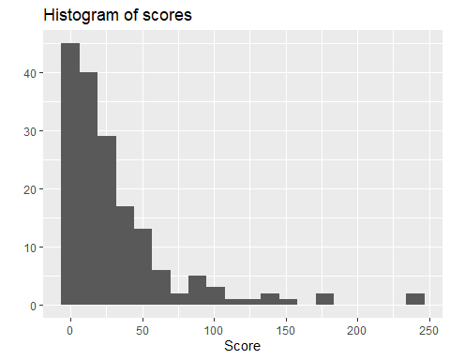 2.2. Describe the distribution of scores, considering shape, location spread and outliers.
*Based on the histogram of scores above, the score data has a strong right-skew, with a median around 0 and four noticable outliers. The level of variation isn’t large.
2.3. Produce a bar chart of the teams participating in the series, with different colours for each team. Noting that each player is represented by 10 rows in the data frame, how many players were used by each team in the series?
Based on the below bar chart, there were 13 unique players on the Australian team during there series, and 14 unique players on the English team
#select only the unique players
bar_chart <- ashes_final %>%
distinct(batter,team)
#plot in a bar chart
ggplot(bar_chart) + geom_bar(aes(team, fill = team)) +labs(x = 'Team', y = '', title = 'Count of unique players on each team')
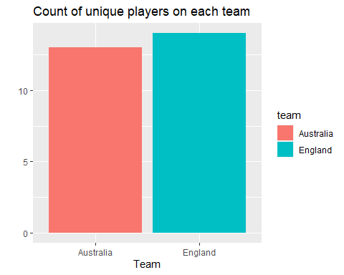

Question 3 Scores for each team
3.1. Using ggplot, produce histograms of scores during the series, faceted by team.
#group up the data to provide a score for each team in each innings in the series
all_scores <- ashes_final %>%
group_by(team,test,innings) %>%
summarise(runs = sum(runs, na.rm=T)) %>%
select(runs, team, test, innings)
#to choose a bin width, one easy way is to use the Freedman-Diaconis rule (which is calculated based on the interquartile range and the rumber of observations), resulting in a bin width of around 133
bw <- 2 * IQR(all_scores$runs) / length(all_scores$runs)^(1/3)
#plot the histogram, with a title and appropriate x lable
ggplot(all_scores,aes(x = runs,fill = team)) +
geom_histogram(binwidth = bw) +
facet_wrap(~team) +
labs(x = 'Score', y = '', title = 'Innings score by team')
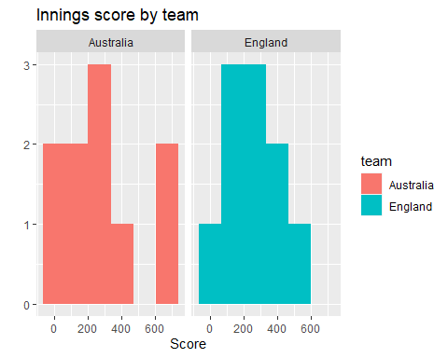
3.2. Produce side-by-side boxplots of scores by each team during the series.
#plot the boxplot
ggplot(all_scores,aes(x = team, y = runs,fill = team)) +
geom_boxplot() +
labs(y = 'Score', title = 'Innings score by team')
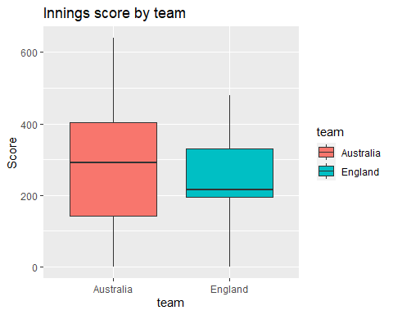
3.3. Compare the distributions of scores by each team during the series, considering shape, location, spread and outliers, and referencing the relevant plots. Which team looks to have had a higher average score?
The score distribution for Australia was broad, with two outlying scores over 600. The median score for Australia was around 300. The distribution for the English scores was much closer to normal, with less a slgiht leftward skew, less deviation and a median around 200.
By examining the boxplot we can see that Australia had the higher average score.

Question 4 Scoring rates
4.1. Produce a scatterplot of scores against number of balls.
#plot the scatter plot, with approrpiate title and labels
ggplot(ashes_final, aes(x = balls, y = runs)) +
geom_point()+
labs(y = 'Score', x = 'Balls', title = 'Score by number of balls faced')
## Warning: Removed 101 rows containing missing values (geom_point).
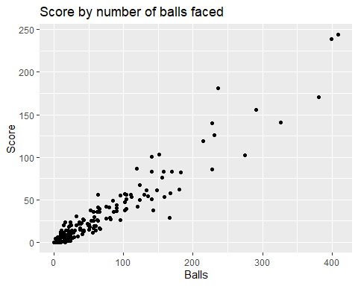 4.2. Describe the relationship between score and number of balls. Are players who face more balls likely to score more runs?
There appears to be a positive correlation between the number of balls faces and the score. This means players who faced more balls scored more runs. An important note is that those players who are struck out after fewer balls are automatically unable to score more runs. There also appears to be more variation in score among instanses of players facing a large (>100) number of balls
4.3. Compute a new variable, scoring_rate, defined as the number of runs divided by the number of balls. Produce a scatterplot of scoring_rate against number of balls.
#compute the new variable using mutate
ashes_final <- ashes_final %>%
mutate(scoring_rate = runs/balls)
#plot the scatter plot, with approrpiate title and labels
ggplot(ashes_final, aes(x = balls, y = scoring_rate)) +
geom_point()+
labs(y = 'Scoring rate', x = 'Balls', title = 'Scoring rate by number of balls faced')
## Warning: Removed 102 rows containing missing values (geom_point).
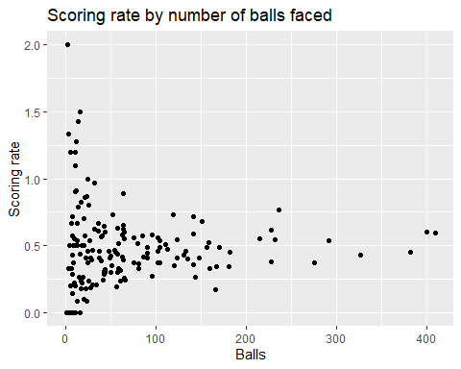
4.4. Is there a relationship between scoring rate and number of balls? Are players who face more balls likely to score runs more quickly?
Based on the above scatterplot, there does not appear to be a relationship between the scoring rate and the number of balls, rather the scoring rate tends to hover between 0.25 and 0.75. Players who face more balls are not really more likely to score runs quicker.

Question 5 Team’s roles
5.1. Produce a bar chart of the number of players on each team participating in the series, with segments coloured by the players’ roles.
bar_chart <- ashes_final %>%
distinct(batter,team,role)
ggplot(bar_chart, aes(x = team, fill = role)) +
geom_bar() +
labs(y = 'Batters', x = 'Team', title = 'Number of batters by team')
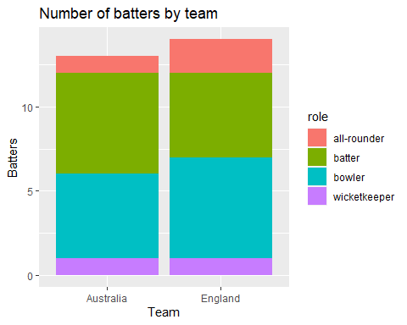
5.2. Produce a contingency table of the proportion of players from each team who play in each particular role.
#produce the base table of players by team and role
bar_chart <- ashes_final %>%
distinct(batter,team,role)
#make the table
bar_chart%>%
group_by(team,role)%>%
summarize(players=n())%>%
mutate(
proportion=round(players/sum(players)*100,1)
)%>%
pander()
team | role | players | proportion
Australia | all-rounder | 1 | 7.7
Australia | batter | 6 | 46.2
Australia | bowler | 5 | 38.5
Australia | wicketkeeper | 1 | 7.7
England | all-rounder | 2 | 14.3
England | batter | 5 | 35.7
England | bowler | 6 | 42.9
England | wicketkeeper | 1 | 7.1
5.3. Using these two figures, state which team is made up of a larger proportion of batters, and which team contains a larger proportion of all-rounders.
There are a larger proportion on batters in the Australian team, and the English team contains a larger proportion of all-rounders.

Question 6. Summary of insights
Cricket Australia are interested in any insights you can bring with respect to the differences between the two teams, as well as any insights related to scoring. In plain English, write a summary of your key findings from Questions 2-5. Your response should be between 200-250 words.
Differences between teams Australian and England had a similar number of players during the series, but the team composition was different, with Australia favouring more specialist batters and England fielding more all-rounder and bowlers.
Australian scores were more variable, with more very low or very high scores. This resulted in a higher average score for Australia than England. England was more consistant with scoring, tending to score around 200 in each game.
Scoring insights
The vast majority of scores in an innings for an individual player are below 50, but the are scores higher that 200 in the series.
Although higher individual scores are strongly relation to the number of balls faced, this is more likely to be an artifact of opperunities to score. The scoring rate of players who faces more balls wasn’t significantly higher than the scoring rate of players who faced less balls.

